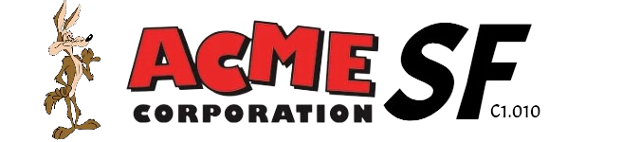

February 16th, 2024

Analysis report

**Repository: https://github.com/C1-010/Acme-SF-D01**

Group: C1.010

García Rivero, Andrés - [andgarriv@alum.us.es](mailto:andgarriv@alum.us.es)

López Cubiles, Antonio José - [antlopcub@alum.us.es](mailto:antlopcub@alum.us.es)

Nieto Vicioso, Javier - [javnievic@alum.us.es](mailto:javnievic@alum.us.es)

Díaz Ordoñez, Pablo -  [pabdiaord@alum.us.es](mailto:%20pabdiaord@alum.us.es)

Sevillano Barea, Alejandro - [alesevbar@alum.us.es](mailto:alesevbar@alum.us.es)

Content Table

1. Executive Summary 2

2. Revision Table 2

3. Introduction 2

4. Contents 2

5. Conclusions 2

6. Bibliography 2

# 1. Executive Summary

This analysis report details each and every problem we have encountered with the requirements and their statements requested on the corresponding sheet. For each one, a verbatim copy of the respective requirement is required, accompanied by detailed conclusions of the analysis conducted along with the decisions made.

# 2. Revision Table

|  |  |  |
| --- | --- | --- |
| Revision number | Date | Description |
| 1 | 14/02/2024 | Creation of the report and completion of its first version. All required information has been provided. |
| 2 | 16/02/2024 | Minor changes. |

# 3. Introduction

# We are facing the individual analysis report for the first delivery. On this occasion, we delve into the requirements entrusted to us, commenting and analyzing the decisions made and conclusions reached during the process of completing them all.

# Regarding the structure of this document, we find an Executive Summary, followed by a Revision Table, the content of the report, which in this case includes a list of analysis records about the completed requirements, a reached conclusion, and finally, the bibliography.

# 4. Contents

Intentionally blank.

# 5. Conclusions

After completing this deliverable, the main conclusion I arrive at is that, in general, all the required requirements have been understood. There were no major complications, and everything was resolved smoothly. The requirements were assimilated correctly and without any problems.

# 6. Bibliography

Intentionally blank.